Albin P James

M200591PH

NIT Calicut

9447029214

[albin_m200591ph@nitc.ac.in](mailto:albin_m200591ph@nitc.ac.in)

KSP2021 Selection

The problem in hand is to analyse the astrometry data of the given comet and to determine its trajectory. The distance of the comet as measured from the earth, b (measured in AU) and the angle between the comet and sun, C are given as shown in figure and the time in earth years (tyears) are given.

**Earth**

**C**

**a**

**Sun**

**B**

**b**

**A**

**c**

**Comet**

To find the trajectory, the distance between comet and sun, c and the angle between comet and earth, B are to be found.

The length ‘c’

c2 = a2 + b2 - 2ab*cos*(C)

The angle ‘B’

*cos*(B) = $\frac{a^{2} + c^{2} - b^{2}}{2ac}$

**Earth**

**Sun**

**B**

**c**

**Comet**

To plot we require the angle the comet and the polar axis makes with respect to sun. For that we calculate the angle EP which is the angle made by Earth and polar axis.

EP = 2*pi*(tyears-(tyears//1))

Now we find the theta to plot by adding this to the angle B corrected for sign.

Plotting c and theta in a polar graph we get

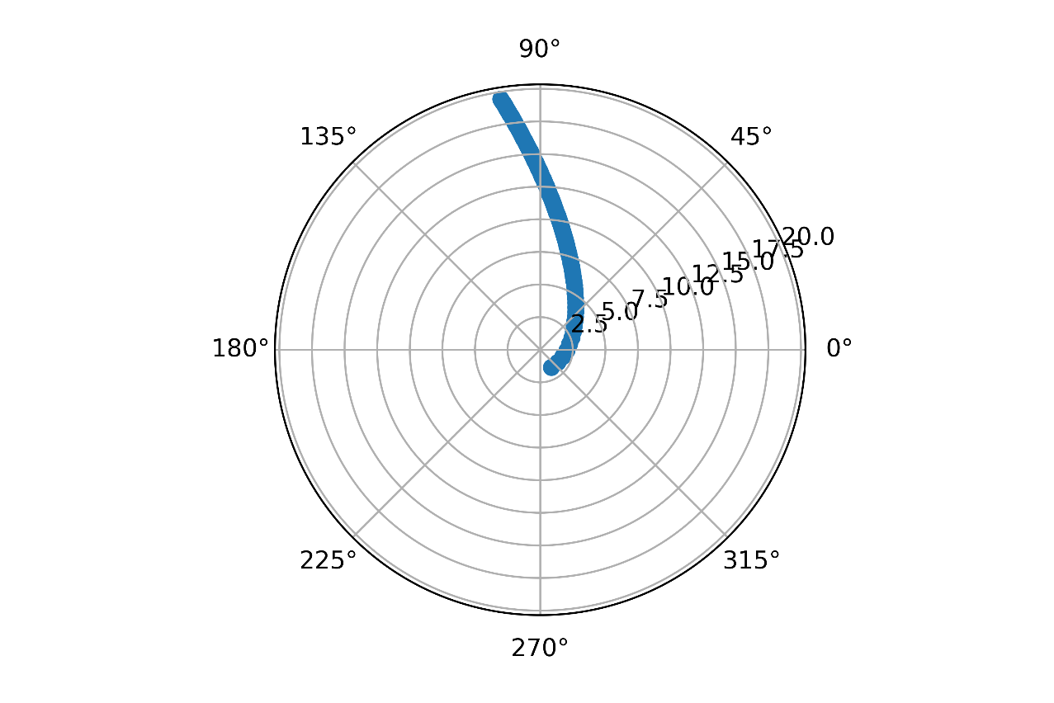

Now we need to find the eccentricity e and the semi latus rectum r0, these are obtained by curve fitting the data to the polar equation of conic sections

𝑟(𝜃)=𝑟0/(𝑒*cos𝜃)

We obtain.

Eccentricity, e = 2.351793828509747

Semi latus rectum, r0 = 12.980348627159088

From the value of eccentricity, we know that it has a hyperbolic trajectory.

The equations for a hyperbolic trajectory are obtained from Wikipedia. <https://en.wikipedia.org/wiki/Hyperbolic_trajectory#Impact_parameter_and_the_distance_of_closest_approach>

From the equation of semi latus rectum we can find the semi major axis.

a_semi = r0/(e**2-1)

Using the equation we find the distance of closest approach or periapsis distance.

periapsis = a_semi*(e-1)

Therefore, we find the trajectory of the comet is **hyperbolic** in nature around the sun and has a periapsis of **3.872657237074253 AU**